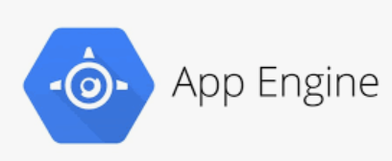

Big Query will get the existing dataset AND perform ML actions (has built-in forecasting capability).





Store forecasting results here.